**LAB NUMBER 10**

**Objective: To implement preserving user state in distributed applications.**

Task: Create a simple Login Logout and Profile page and use cookie to preserve user state but use MVC Architecture.

Index.html

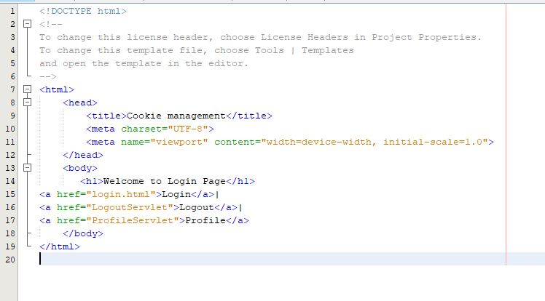

Login page

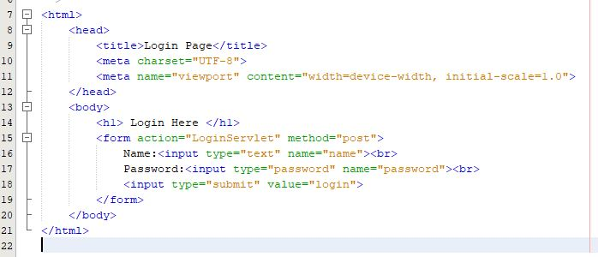

Login servlet:

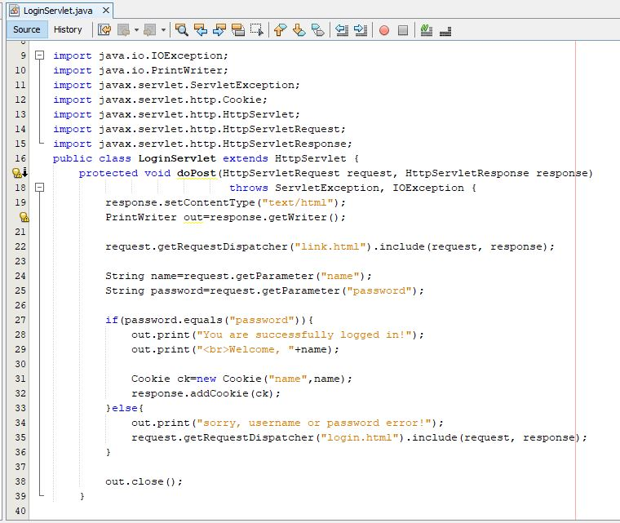

Logout Servlet:

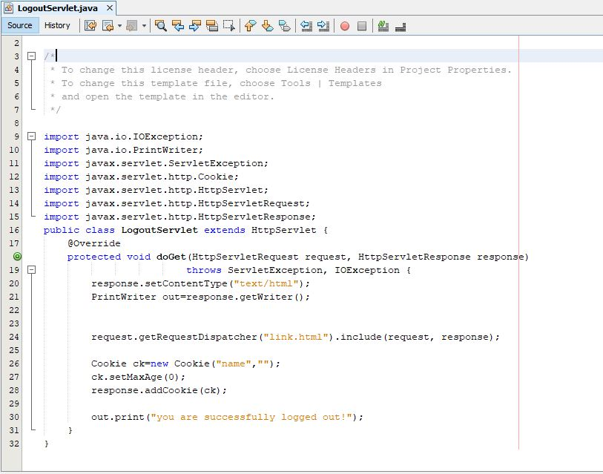

Profile Servlet:

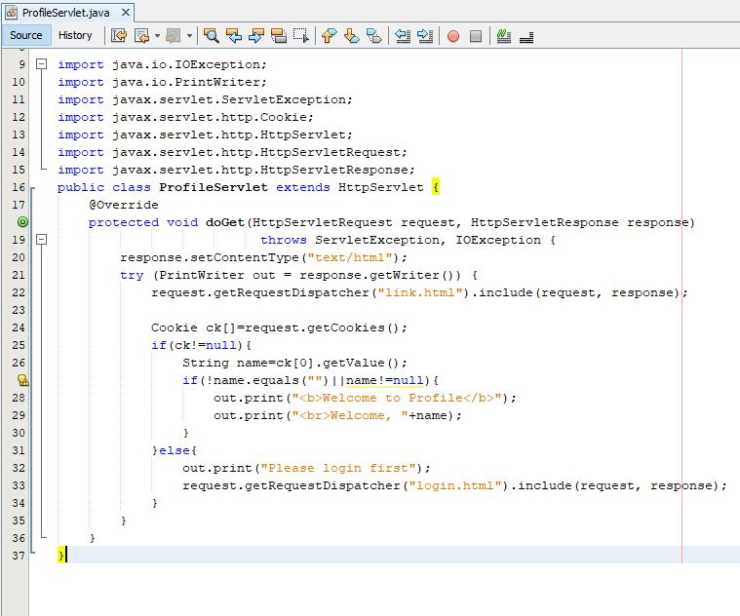

Results:

